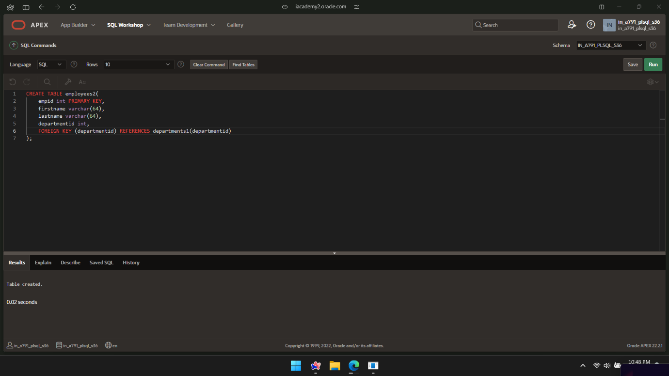

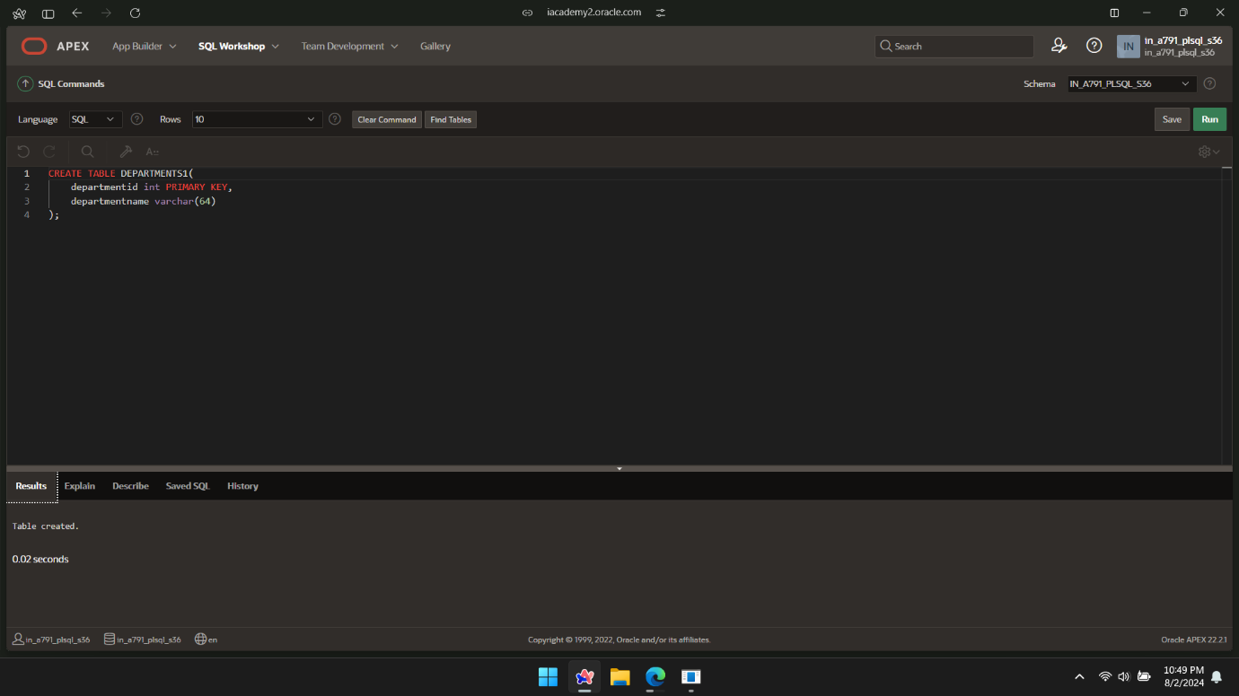

DECLARE

TYPE person_dept IS RECORD

(firstname employees2.firstname%TYPE,

lastname employees2.lastname%TYPE,

departmentname departments1.departmentname%type);

v_person_dept_rec person_dept;

BEGIN

SELECT e.firstname,e.lastname,d.departmentname INTO v_person_dept_rec

FROM employees2 e JOIN departments1 d ON e.departmentid =d.departmentid

WHERE empid=2;

DBMS_OUTPUT.PUT_LINE(v_person_dept_rec.firstname||' '|| v_person_dept_rec.lastname||' '||v_person_dept_rec.departmentname);

END;

/

